|  |
| --- |
| IdentiFY Project |
| FitLike Software Documentation |
| User Guide 1.0 |

|  |
| --- |
| Manuel Petit  14/12/2018 |

# General presentation

## Introduction

FitLike sofware was develop to help data processing from STELAR© SPINMASTER FFC2000. It allows to :

* Process bloc data to obtain dispersion curves
* Customize pre-processing methods and models
* Visualize and explore dispersion, zone and bloc data
* Create, apply and export dispersion models

## Installation/Running

FitLike software requires MATLAB© 2014b or upper versions and the following toolbox:

* Curve Fitting ToolBox
* Statistic and Machine Learning ToolBox
* Image Processing ToolBox

*Note : Statistic and Machine Learning ToolBox & Image Processing ToolBox could be avoided by changing the source code.*

### Running FitLike

Step 1 : Download all the files and folder from the following GitHub link : https://github.com/ManuIdentiFY/FitLike2

Step 2 : Unzip the files and put them in the same folder.

Step 3 : Open MATLAB© and run FitLike with **launcher()**

# Interface presentation

FitLike software is composed by a menu and three main figures (Fig. 1) :

* File Manager : visualisation, selection and organisation of the imported files
* Display Manager : data and model visualisation (bloc, zone, dispersion)
* Model Manager : data pre-processing and model training

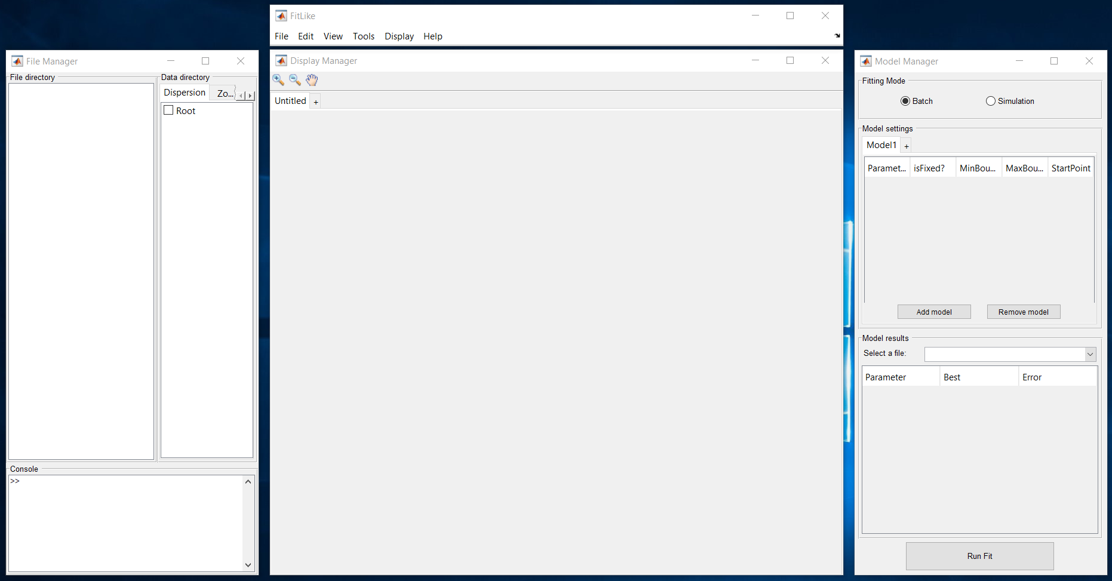

Fig. 1 : FitLike interface - menu and three main figures

Each figure can be set invisible by closing it (red cross at the top right corner of the figure). Using **Display > …** the figure can be set visible or invisible.

# STELAR© files : importation, organisation

## Importation

FitLike software allows the importation of STELAR© files from SPINMASTER FFC2000 (.sdf/.sef). FitLike software can manage two versions of the STELAR© files : version 1.0 and 2.0. Files are imported and organised as Dataset>Sequence>File.

1. **File > Open file**

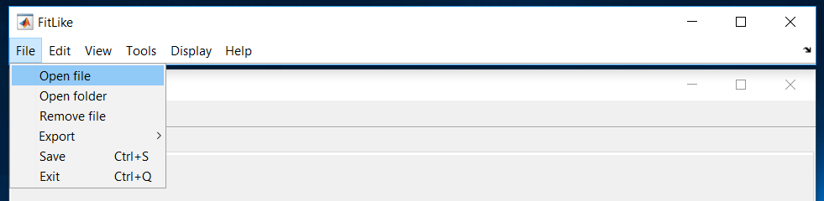

Fig.  : Import .sdf Files

1. Select **.sdf, .sef or .mat files**

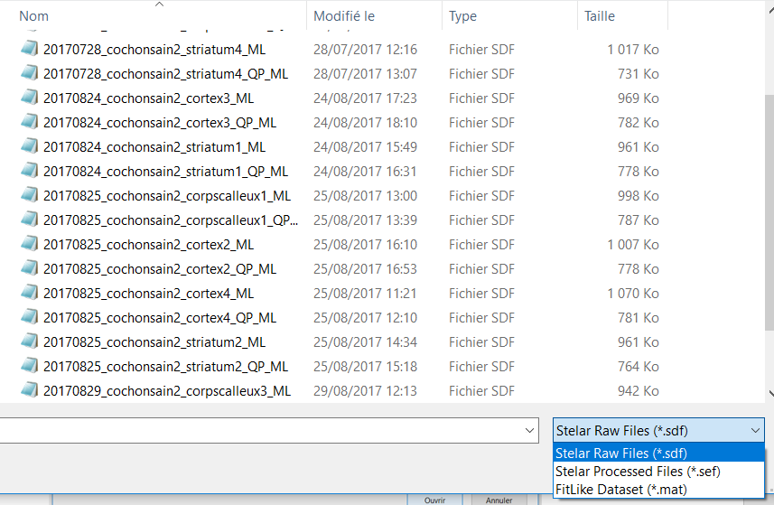

Fig. 3 : Importation window

*Note : You can select multiple files at the same time. Also .mat files corresponds to files saved in FitLike (see Save Working Space).*

1. Enter a dataset name or select an existing one
2. Your files appear in the File Manager File directory (Fig. 4)

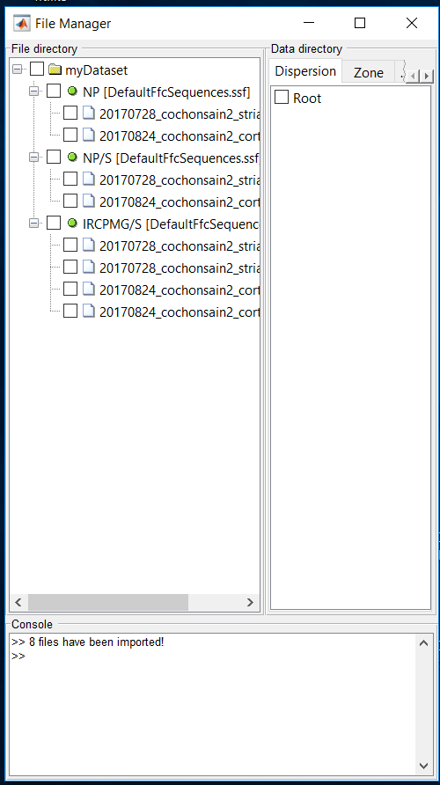

Fig. 4 : File Manager panel after importation

*Note: It is also possible to import directly folder containing the raw data using* ***File > Open Folder****.*

## Organisation

### Rename Dataset/Sequence/File

You can rename dataset/sequence/file by clicking on them in the FileManager File directory tree and **Enter**. See Fig. 5. No duplicated are accepted.

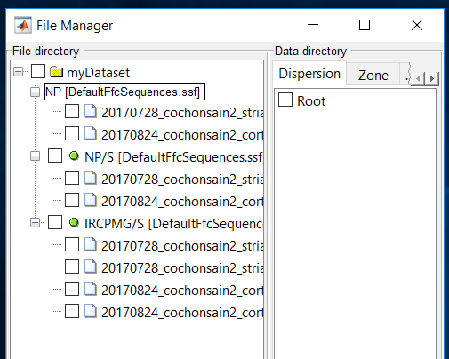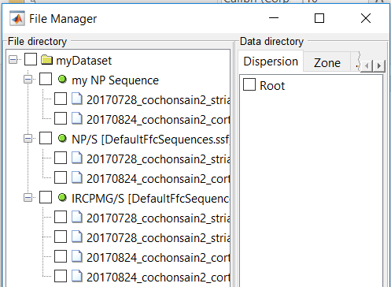

Fig. 5 : Rename files (left: before, right: after)

### Select files

You can select or unselect files by clicking on the checkbox at the left of the dataset/sequence/file in the File Manager file directory tree (Fig. 6).

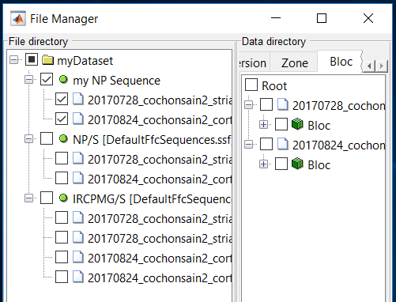When you select files, data containing inside the files appear in the Data directory. According to the data, you can see them in Dispersion/Zone/Bloc (If you import .sdf files, only Bloc are visible before applying processing).

Fig. 6 : Select files. Bloc data appear in the Data directory (Bloc panel).

### Select data

When you have selected files you can then select data in the data directory. Data will appear in the DisplayManager.

Take care about Bloc/Zone data where you can expand data to select a specific zone/bloc.

### Remove files

Files can be removed by using **File > Remove file.**

### Future functions

* Drag and Drop to move dataset/sequence/file
* Merge/Unmerge files
* Add label to files

# STELAR© files : processing

The imported files can be processed using different functions. Precisely raw data (.sdf) can be treated to obtain dispersion data following:

Each arrow corresponds here to a specific process.

## Processing Manager presentation

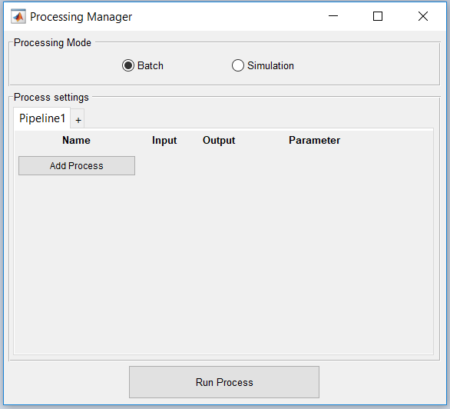The ProcessingManager figure can be open with **Display > ProcessingManager.**

Fig. 7: Processing Manager figure

Two processing mode can be used:

* Batch: allow to treat multiple files with the same pipeline
* Simulation: allow to treat one file with multiple pipeline (not available)

In the Process settings, process pipeline can be created by clicking on **Add Process**. Description of each process will be available soon in the interface but can be found in Data Controller folder.

After selection, the process appears in the current pipeline. Input and Output displays the input and output type of the process (here from bloc to zone).

Arrows and red cross allow to move up/down or supress a specific process.

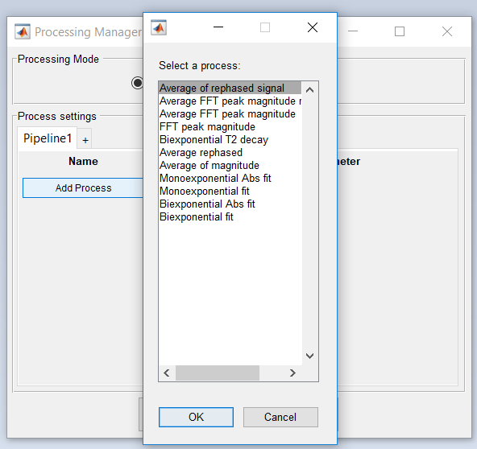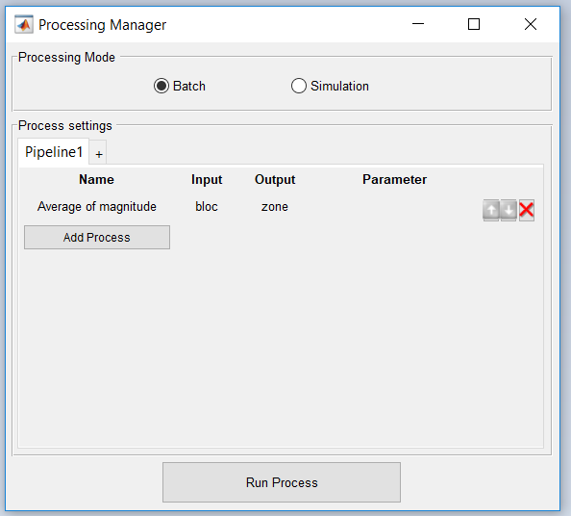

Fig. 8: Process selection window and result after selection

## Processing Manager – Pipeline options

You can add new pipeline by clicking on the **“+” tab**. Just left click on another tab to select it.

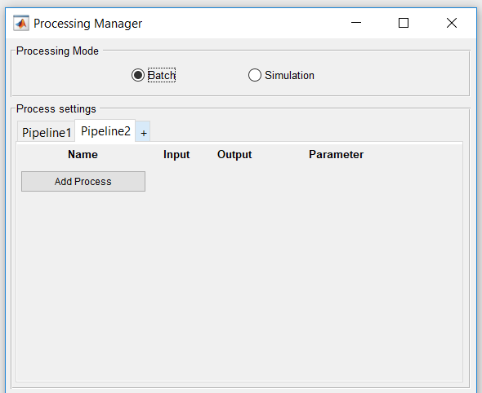

Fig. 9: New pipeline can be added by clikcing on the '+' tab

By right clicking on a specific tab (other than ‘+’ tab), you access several options:

* Rename the pipeline
* Load a saved pipeline
* Save the selected pipeline
* Delete the selected pipeline

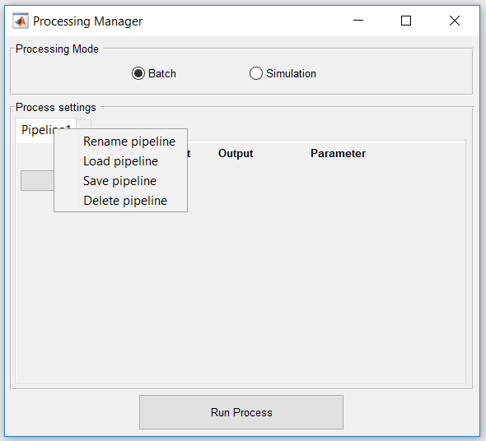

Fig. 10: Tab options available (right click)

## Processing Manager – Run process

After selecting the processing mode and designing your pipeline you can run it by clicking on **Run Process**. Results will be automatically displayed in the DisplayManager if possible.

Do not forget to select files in the FileManager (file directory tree).

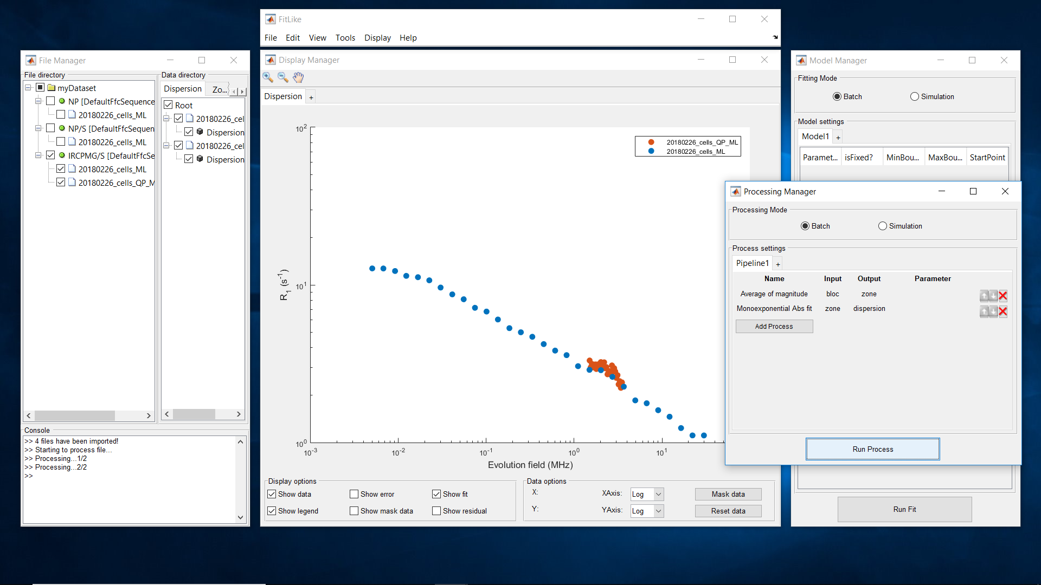

Fig. : dispersion result after processing

# STELAR© files : visualisation, exploration

This part is mainly dedicated to the DisplayManager presentation and the visualisation options available.

Before introducing the DisplayManager window you need to select data you want to display. See **III-B** to select files then data. Do not forget that Zone and Dispersion data appear only after processing (except if you are using .sef files).

*Note: The process function used are indicated briefly in the data directory (here Dispersion T1 🡪 monoexponential fit; Zone Abs 🡪 Magnitude averaged).*

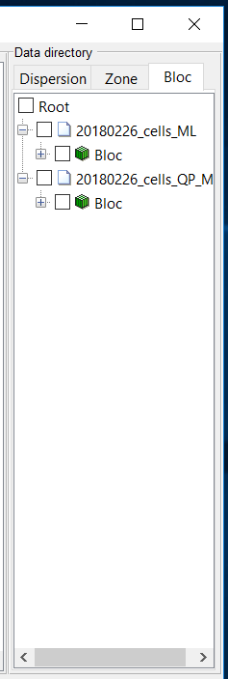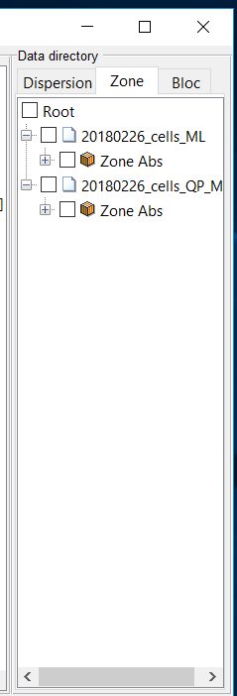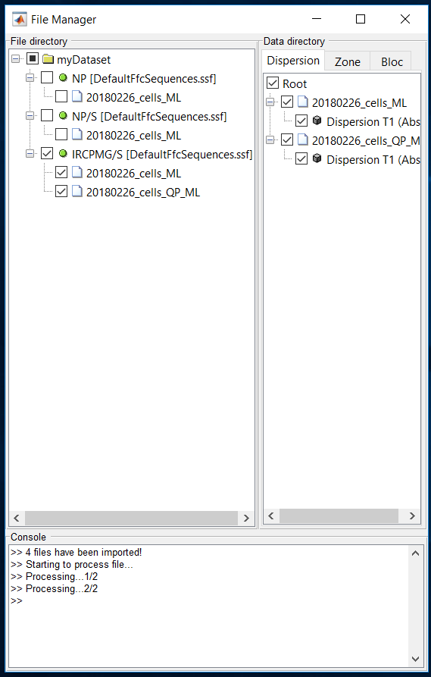

Fig. 12: Dispersion/Zone/Bloc Data

When you want to visualise data, two cases are possible:

* If the selected tab in DisplayManager is empty you can select any data type (dispersion, zone, bloc). The selection of data changes automatically the empty tab into an appropriate tab.
* If the selected tab in DisplayManager is already a dispersion, zone or bloc you can only add or remove the same type of data. If you try to display other type of data, an error message will appear in the console.

As in ProcessingManager, you can add new tab by clicking on the **‘+’ tab** or remove specific one by right clicking on the unwanted tab and select **Close Tab**.

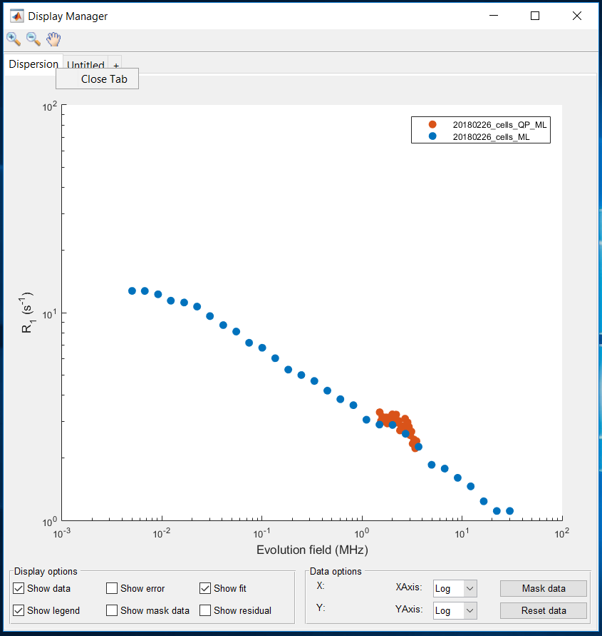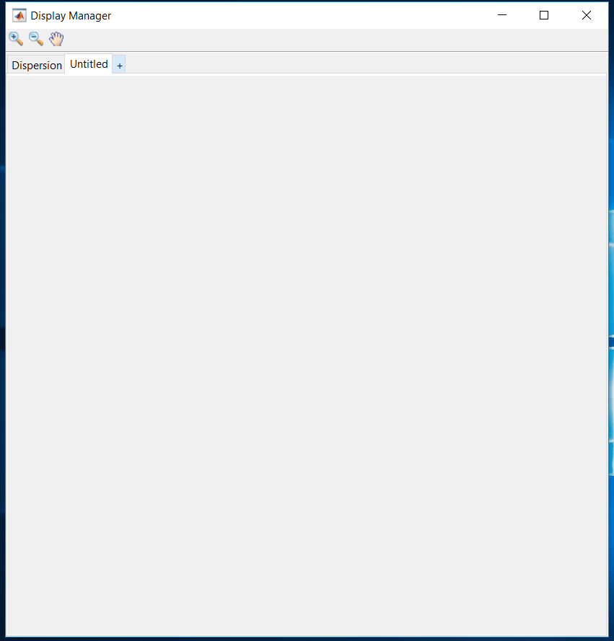

Fig. 13: DisplayManager tab system. You can add new tab by clicking on the ‘+’ tab or you can remove specific tab by right clicking on it and select ‘close tab’. here the new tab “untitled” accept any type of data whereas the dispersion tab accept only dispersion data.

## Dispersion tab

In the dispersion tab, different display options are available:

* Show data: set visible or invisible the data (include error and masked data)
* Show error: set visible or invisible data errors
* Show fit: set visible or invisible models applied on the data (See VI for dispersion curve modelisation)
* Show legend
* Show mask data: set visible or invisible the masked data
* Show residual: set visible or invisible the residuals from the applied model. No residuals are displayed if no fit were applied (See VI for residuals).

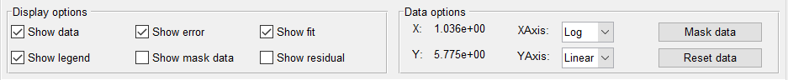

Fig. 14: Display and data options available in dispersion tab.

In the data options panel, you can see the X-Y values of the mouse position. Axis can be customised between linear and logarithmic scaling. Finally, you can mask some unwanted data by clicking on **Mask data** or reset all the mask by using **Reset data**.

*Note: Masked data are not taken in account during fit process and are indicated by the ‘+’ symbol.*

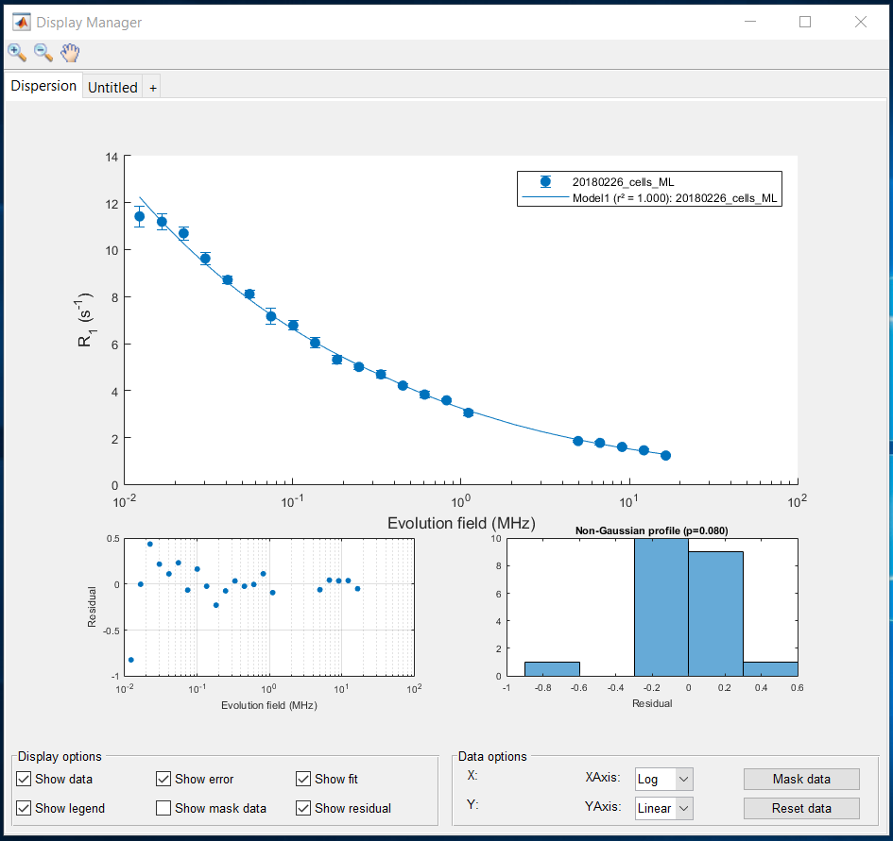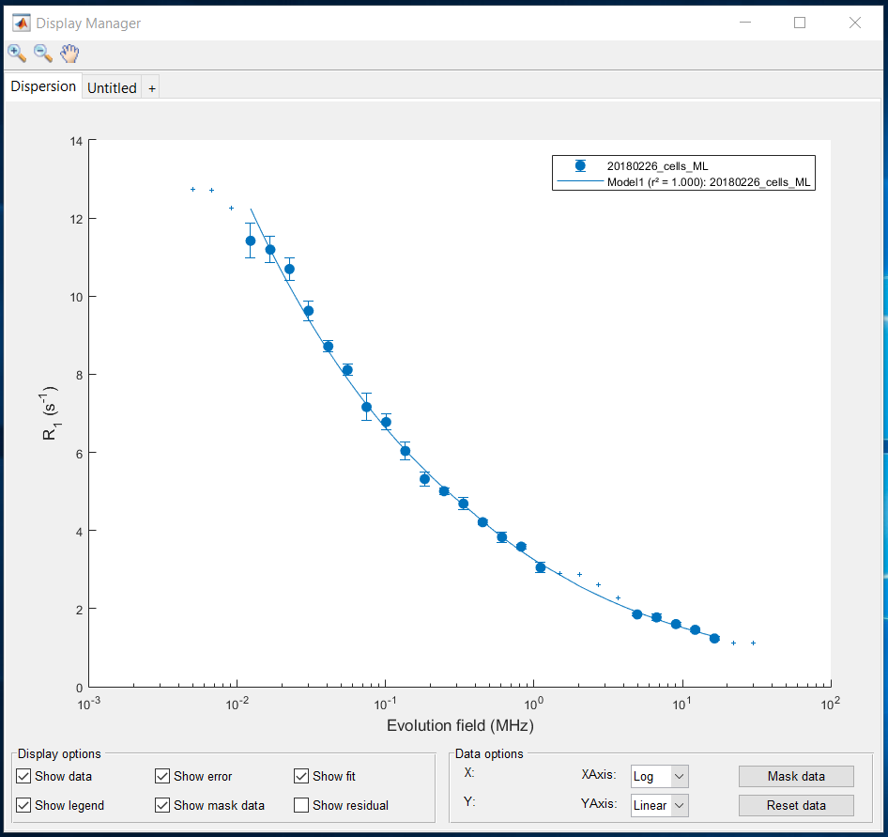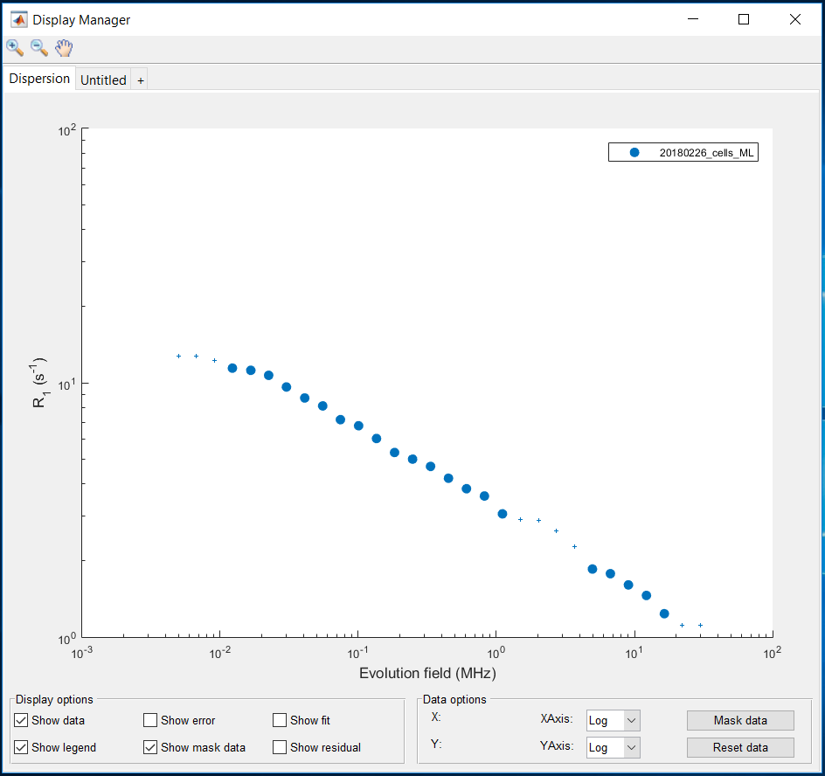

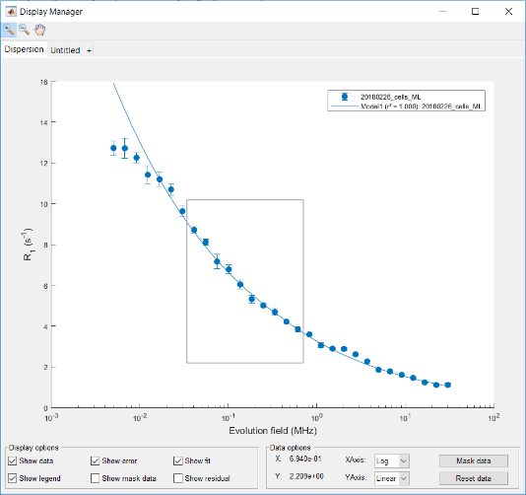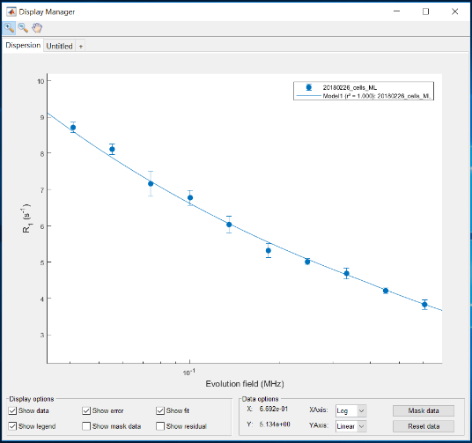**Zoom in/out** and **pan** are available above the tab. To use it left click on one of the symbol then on any available axis. A black cross or hand will appear for the zoom or pan respectively.

Fig. 15: Examples of possible visualisation in dispersion tab. Top-left: only data and masked data. Top-right: data, error, masked data and fit. Bottom: data, error, fit and residuals. Note the scaling difference according to the y-axis.

Fig. 16: Zoom in before/after

In order to simplify the visualisation of the underlined zone data, it is possible to directly click on any dispersion point to get its zone data and fit. A black square appears at the selected point while the main axis is split into two sub axis.

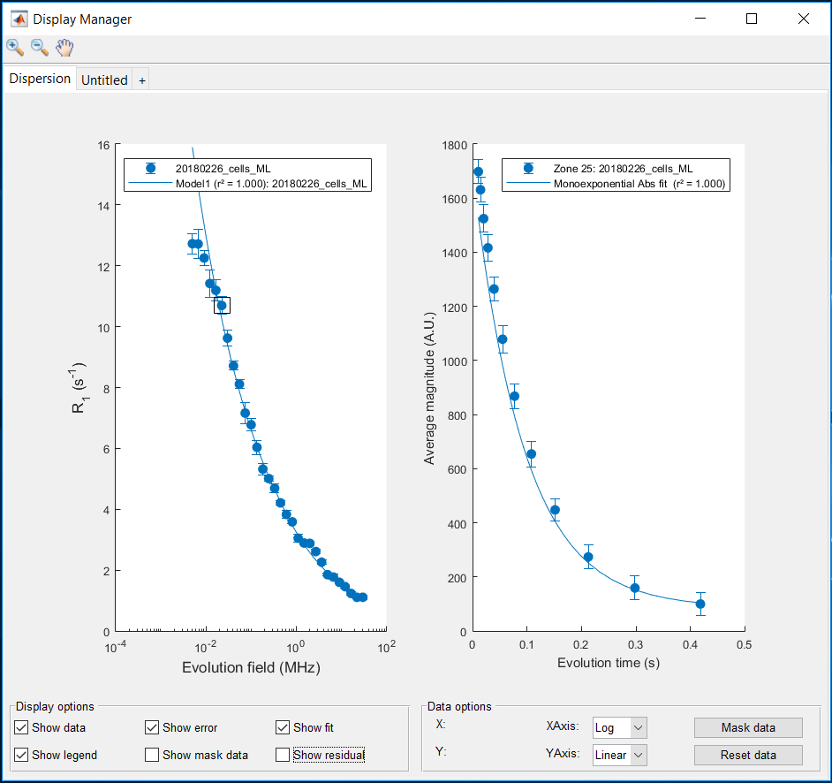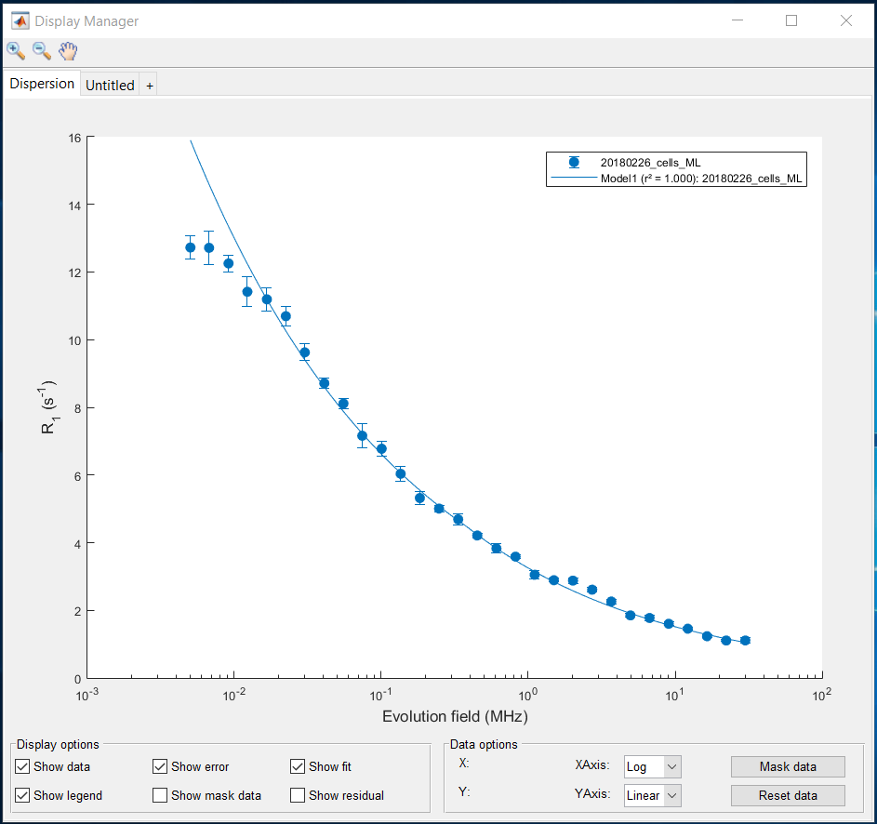You can change the selected point by clicking on any other dispersion data as well as remove the current selected point by clicking again on it.

Fig. 17: Clicking on a specific dispersion point results in the apparition of its zone data. The selected point can be removed by clicking on the same dispersion point again.

*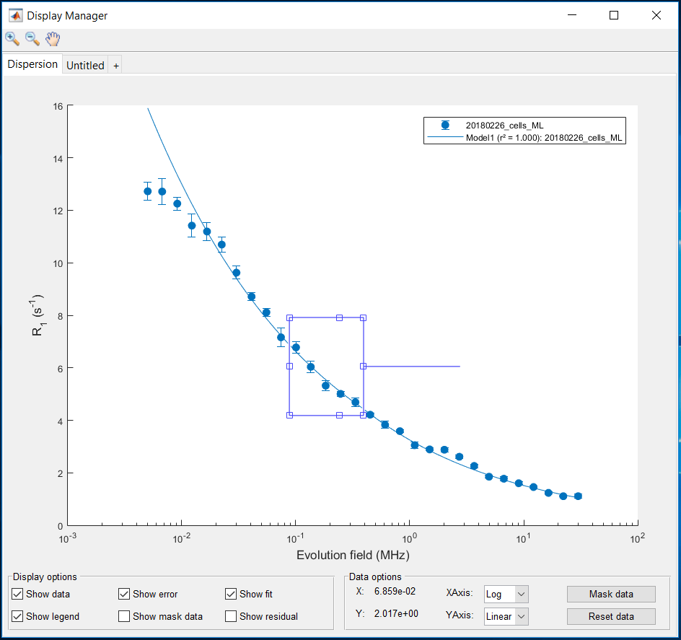Note: When you are clicking on* ***Mask data*** *a black cross appears to replace the mouse. Left click and hold to create the rectangular shape corresponding to the data you want to mask. If you have missed your shape you can change it by clicking on any empty squared surrounding your rectangle and adjusting them. When it is done double click on the rectangle to validate your selection.*

Fig. 18: Draggable rectangle created after clicking on Mask data

## zone tab

The zone tab is exactly the same than the dispersion one. An important point however is the selection of the zone data in the data directory: in order to select only some data you need to expand the main zone icon (orange cube) and select only the zone you want to see.

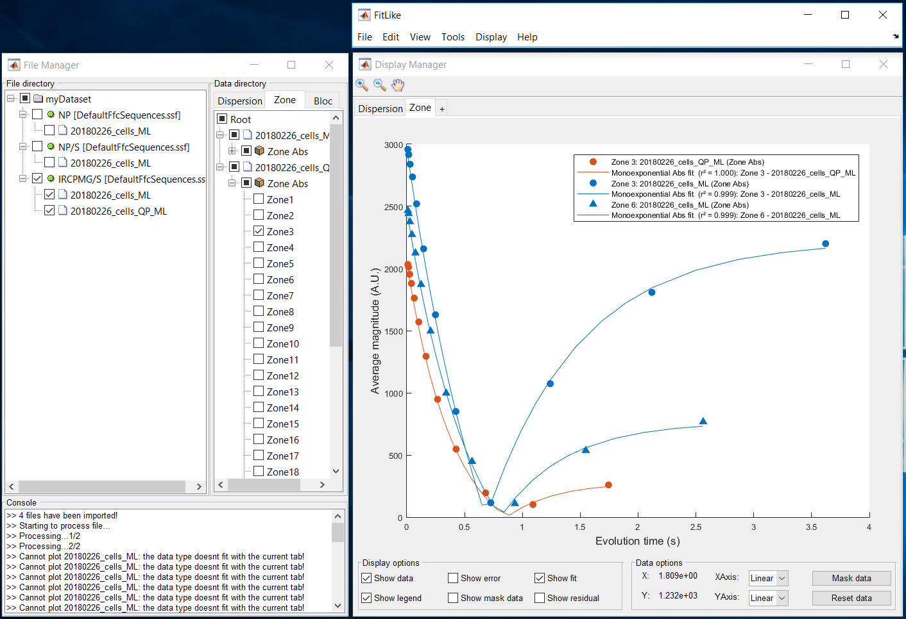

Fig. 19: Zone tab visualisation. If multiple curves are coming from the same file they are plotted using different markers.

*Note: The selected point function that allows to see the underlined bloc data is not available for the zone tab.*

*Note2: In further version, the 2d plot will be completed by a 3d plot allowing the visualisation of the complete zone dataset.*

## Bloc tab

Not available yet :/

# STELAR© files : Modelisation

The right window in FitLike called ModelManager allows to fit dispersion models to the dispersion data.

*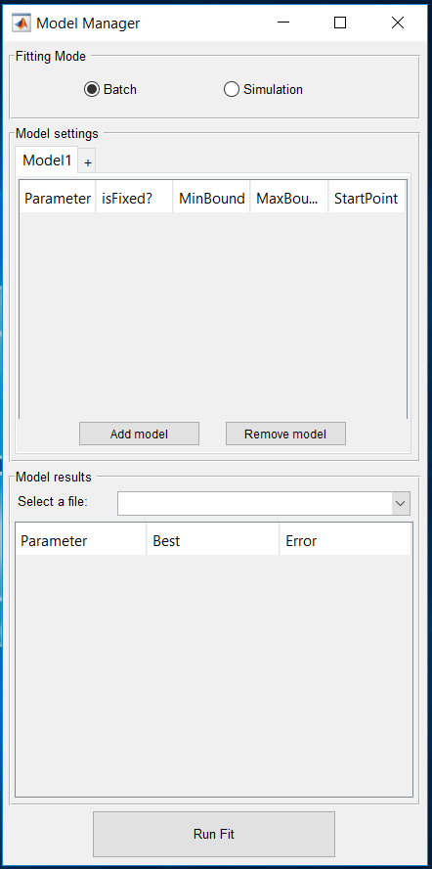Note: These models are only available for dispersion data (not zone or bloc).*

Fig. 20: Model Manager

It is composed of three part:

* Fitting mode: allow to fit multiple models to one dispersion curve (simulation) or one model to multiple dispersion curves (batch). Similar to ProcessingManager.
* Model settings: allow to add, remove or change models. Model(s) can be composed by the addition of multiple models. Behavior of this part is similar to process settings in ProcessingManager (See IV-2).
* Model results: allow to visualise the coefficients obtained after applying the model.

*Note: Simulation mode is not available yet* ☹.

## ADd, Remove, Change models

In the Model settings, you can customise the applied model(s). It is based on a tab system (like in Processing Manager) where you can add new model pipeline using the ‘+’ tab and access different options by right-clicking on a specific tab. Options are:

* Rename model pipeline
* Load model pipeline
* Save model pipeline
* Delete model pipeline

You can add or remove model(s) in a specific model pipeline using **Add model** and **Remove model**. 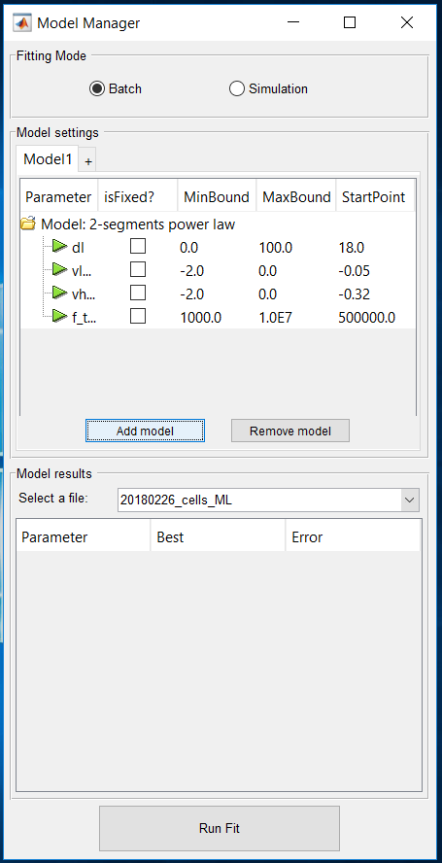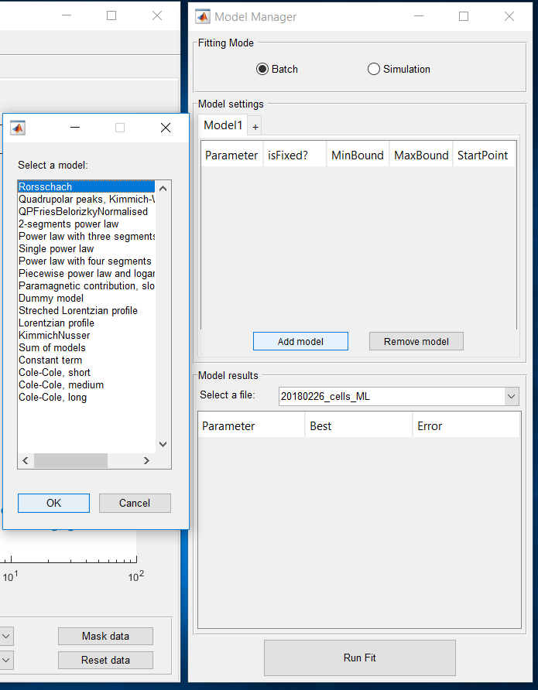

Fig. 21: Add model to a specific model pipeline (here model1). After model selection (left) it appears with its associated coefficients in the model pipeline (right).

After adding models, it is possible to change the boundaries (**minBound** and **maxBound**) as well as the start point (**StartPoint**). Finally, you can fix one or several parameters using the **isFixed?** checkbox.

*Note: Be aware that minBound < StartPoint < maxBound need to be true to set new values! Check the console in FileManager!*

## Run fit and visualise results

After designing the model pipeline you want to apply (with one or multiple model) and selecting some dispersion data to fit, you can press **Run Fit**.

The fit result should appear in the Display Manager as well as in the model results panel. You can use the selection box at the right of **Select a file:** to get the fit results.

*Note: Do not forget that you need to select dispersion data if you want to see their fit results!*

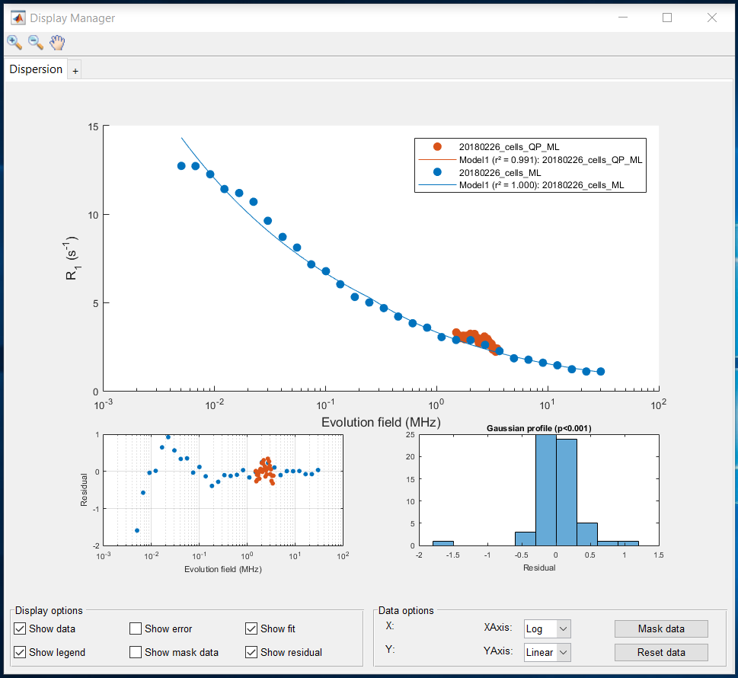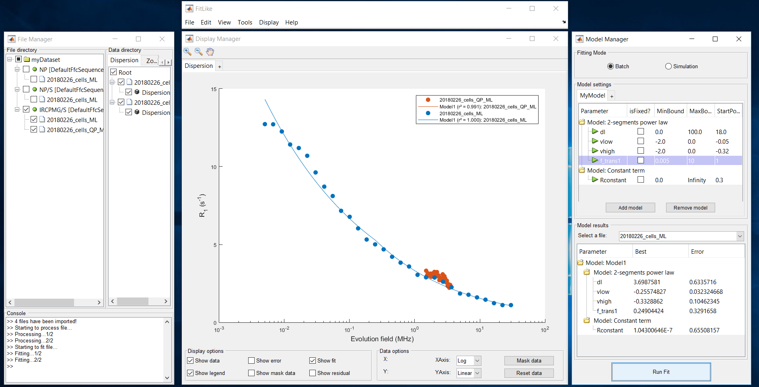You can use **Show residual** at this step to visualise the fit efficiency.

Fig. : Residual plot

Fig. 22: Result after fitting MyModel to the data

# FitLIke Data : Save, export

## Save workspace

At any time, you can save the workspace using **File > Save**. It includes all the files you have imported, their associated processing and fit(s) data. However, it does not include the graphical options (display options, tree display, file selected...).

After saving your workspace, you will obtain a .mat file that you can re-open using **File > Open** and select **.mat file**.

## export results

### Dispersion data

You can export dispersion data using **File > Export > Dispersion data**. Do not forget to select the file you want to export before.

Files are export as .txt file (can be import in Excel) and organise individually as:

Header lines:, 14,

HEADER,

Date:, 07-Jan-2019,

Dataset:, myDataset,

Sequence:, IRCPMG/S [DefaultFfcSequences.ssf],

Filename:, 20180226_cells_ML,

Label:, ,

PROCESSING:,

1, Average of magnitude, Bloc2Zone,

2, Monoexponential Abs fit, Zone2Disp,

DATA:,

X, Y, DY,

29.999782, 22.228091, 16.461744,

12.196689, 9.038006, 6.693659,

4.959782, 3.675276, 2.723072,

…

If multiple Y-values are available (ex: biexponential fit) DATA is organised as:

X, Y1, DY2, Y2, DY2,…

### Fit results

Not available yet ☹